1. Console "Hello Word" in document.ready function

<html>

<head>

<script src = "https://ajax.googleapis.com/ajax/libs/jquery/3.2.1/jquery.min.js"></script>

</head>

<body>

<script>

$(document).ready(function()

{

console.log("Hello world");

});

</script>

</body>

</html>

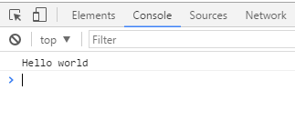

1. Select a ID name "#test" and add class "load" when DOM is loaded

<html>

<head>

<script src = "https://ajax.googleapis.com/ajax/libs/jquery/3.2.1/jquery.min.js"></script>

</head>

<body>

<div id = "test"></div>

<script>

$(document).ready(function()

{

$('#test').addClass('load');

});

</script>

</body>

</html>

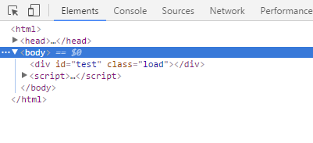

1. Change the color of element which class name end with "-new"

<html>

<head>

<script src = "https://ajax.googleapis.com/ajax/libs/jquery/3.2.1/jquery.min.js"></script>

</head>

<body>

<div class = "newer"> This is newer class div </div>

<div class = "test-new"> This is new class div </div>

<script>

$(document).ready(function()

{

$("[class$=-new]").css("background-color","pink");

});

</script>

</body>

</html>

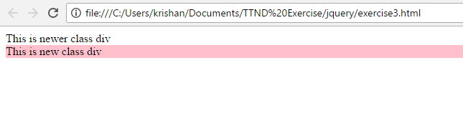

1. Disable submit button using jquery attr method

<html>

<head>

<script src = "https://ajax.googleapis.com/ajax/libs/jquery/3.2.1/jquery.min.js"></script>

</head>

<body>

<button type = "submit">Submit</button>

<script>

$(document).ready(function()

{

$(':input[type="submit"]').attr('disabled', true);

});

</script>

</body>

</html>

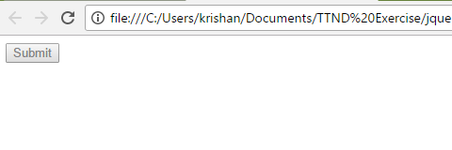

1. Change the font size of ".target" which has parent element with id name "#main"

<html>

<head>

<script src = "https://ajax.googleapis.com/ajax/libs/jquery/3.2.1/jquery.min.js"></script>

</head>

<body>

<div id ="main">

<div class="target">

This is target class

</div>

</div>

<script>

$(document).ready(function()

{

$('#main > .target' ).css('font-size', 28);

});

</script>

</body>

</html>

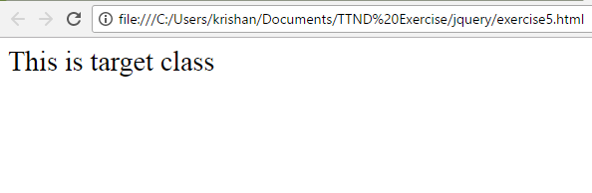

1. After page load change the HTML of div element with "p" element

<html>

<head>

<script src = "https://ajax.googleapis.com/ajax/libs/jquery/3.2.1/jquery.min.js"></script>

<script>

$(document).ready(function()

{

var p = $('p').html();

$('div' ).html(p);

});

</script>

</head>

<body>

<div id ="main">

<div class="target">

This is target class

</div>

<p> This is p element</p>

</div>

</body>

</html>

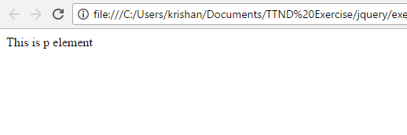

1. Bind a click function to an "click" element and append next "click" next to it.

<html>

<head>

<script src = "https://ajax.googleapis.com/ajax/libs/jquery/3.2.1/jquery.min.js"></script>

</head>

<body>

<button class = "click">Click</button>

<script>

$('.click').click(function()

{

var r= $('<input type="button" value="Click"/>');

$("button").after(r);

});

</script>

</body>

</html>

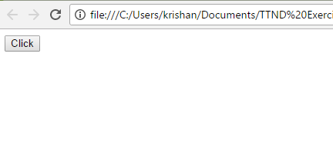

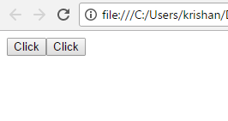

1. Click event not working on element which added dynamicly or via script, make it work using .on method

<html>

<head>

<script src = "https://ajax.googleapis.com/ajax/libs/jquery/3.2.1/jquery.min.js"></script>

</head>

<body>

<!-- <input type="button" value="Click" class ="click"> -->

<div></div>

<script>

var r= $('<input type="button" value="Click" class ="click1">');

$("div").after(r);

$('.click1').on('click',function()

{

var p= $('<input type="button" value="Click" class ="click">');

$(".click1").after(p);

});

</script>

</body>

</html>

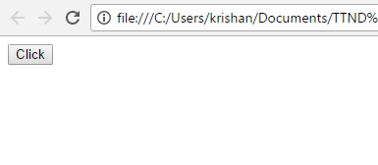

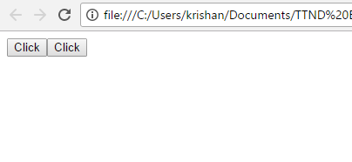

1. Get dropdown selected value on onchanage event and append in div container

<html>

<head>

<script src = "https://ajax.googleapis.com/ajax/libs/jquery/3.2.1/jquery.min.js"></script>

</head>

<body>

<!-- <input type="button" value="Click" class ="click"> -->

Operating systems:<br/>

<select name="os" class="menu">

<option value="Windows XP">Windows XP</option>

<option value="Windows 7">Windows 7</option>

<option value="Windows 8">Windows 8</option>

<option value="Windows 9">Windows 9</option>

</select><br/><br/>

<div> Selected options are:</div>

<script>

$('.menu').on('change',function()

{

// var p= $(.menu).val();

var p = $(".menu option:selected").text();

$('div').append('<br/>'+p);

});

</script>

</body>

</html>

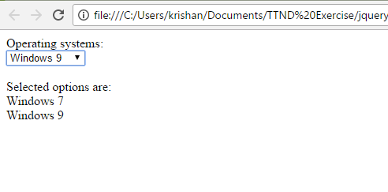

1. Create a dropdown menu using hover method in jquery

<html>

<head>

<script src="https://ajax.googleapis.com/ajax/libs/jquery/3.2.1/jquery.min.js"></script>

<style>

li {

float: inherit;

}

</style>

</head>

<body>

<ul>

<li class="btn">

Drinks

<ul class="sub-menu" style="display: none;">

<li>Fruit juice</li>

<li>Tea</li>

<li>Coffee</li>

<li>Milk</li>

</ul>

</li>

</ul>

<script>

$('.btn').mouseover(function() {

$(this).find('.sub-menu').slideDown(200);

});

$('.btn').mouseleave(function() {

$(this).find('.sub-menu').slideUp();

});

</script>

</body>

</html>

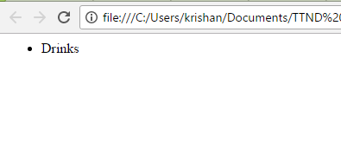

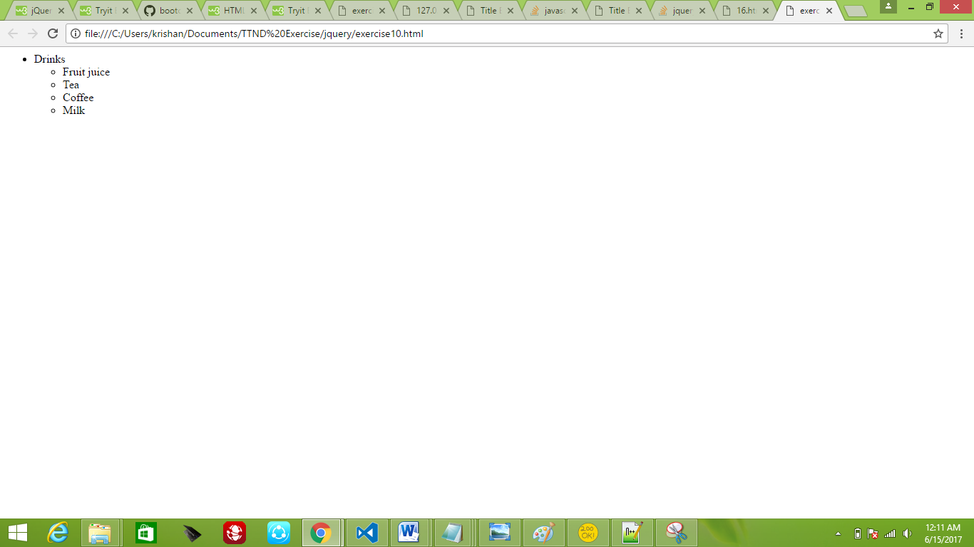

1. On clicking on "[google](https://www.google.com/)" tag. It is taking us to google home page. Stop it from happening

<html>

<head>

<script src="https://ajax.googleapis.com/ajax/libs/jquery/3.2.1/jquery.min.js"></script>

</head>

<body>

<a href="https://www.google.com">google</a>

<script>

$(function() {

$("a").click(function() {

event.preventDefault();

});

});

</script>

</body>

</html>

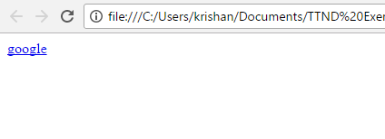

1. We have bind a click funtion to parent div but we want stop it from performing when user clicks on its child li

<html>

<head>

<script src="https://ajax.googleapis.com/ajax/libs/jquery/3.2.1/jquery.min.js"></script>

<script>

$(document).ready(function() {

$("li").click(function(event) {

event.stopPropagation();

var msg = $(this).html();

alert( msg + "was clicked");

});

$("ul").click(function() {

alert(" The 'ul' element was clicked");

});

});

</script>

</head>

<body>

<ul>

Heading

<li>This is first li element.</li>

<li>This is second li element.</li>

</ul>

</body>

</html>

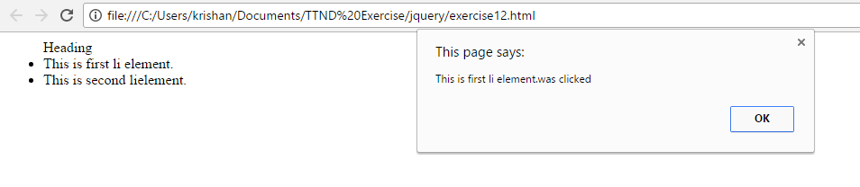

1. Get the max height of elements using jquery each method

<html>

<head>

<script src="https://ajax.googleapis.com/ajax/libs/jquery/3.2.1/jquery.min.js">

</script>

<script>

$(document).ready(function() {

$("button").click(function() {

$("div.a").each(function() {

alert(Math.max.apply(Math, $("div.b", this).map(function() {

return $(this).height();

})));

});

});

});

</script>

</head>

<body>

<button>Max Height</button><br/>

<div class="a">1.

<div class="b">Hi</div>

<div class="b">Hello<br/> Hey!

</div>

<div class="b">World</div>

<div class="b"></div>

</div><br/>

<div class="a">2.

<div class="b"></div>

<div class="b">Thanks</div>

</div><br/>

<div class="a">3.

<div class="b"></div>

<div class="b"></div>

<div class="b"></div>

</div>

</body>

</html>

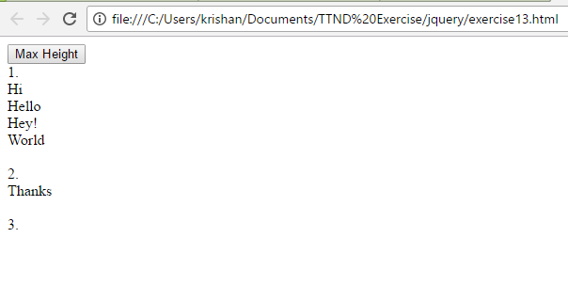

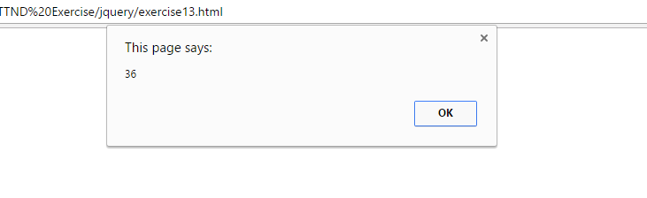

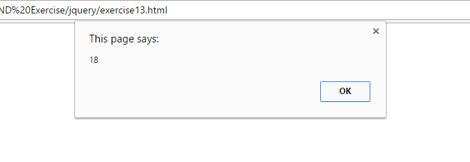

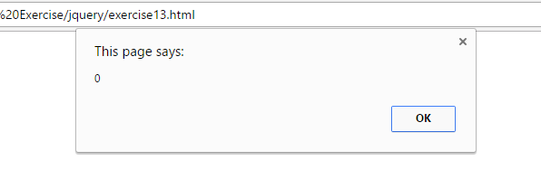

14. Chagne color of every cell which has number larger than 10.

<html>

<head>

<script src="https://ajax.googleapis.com/ajax/libs/jquery/3.2.1/jquery.min.js"></script>

<title>

Table

</title>

</head>

<body id="test" class="body-new">

<div id="main" class="tothenew">

Enter Number:-

<input class="s_input">

<button class="s_btn">Add</button>

</div>

<table>

<thead>

<tr>

<th>Number</th>

</tr>

</thead>

<tbody id="s_add">

<tr>

</tr>

</tbody>

</table>

<script>

$(document).ready(function(){

$('.s_btn').click(function(){

if($('.s_input').val()>10)

{$('#s_add').append('<tr><td style="background:red;">'+$('.s_input').val()+'</td></tr>');}

else

{

$('#s_add').append('<tr><td>'+$('.s_input').val()+'</td></tr>');

}

});

});

</script>

</body>

</html>

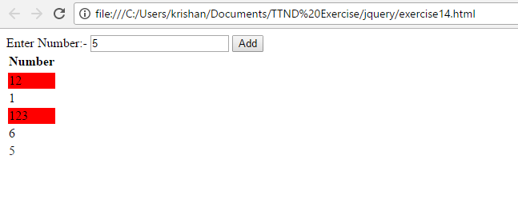

**15.** Retrive the data from server using ajax get call

<html>

<head>

<!-- <script src = "https://ajax.googleapis.com/ajax/libs/jquery/3.2.1/jquery.min.js"></script> -->

</head>

<body>

<button type = "submit"> Submit </button>

<script src = "https://ajax.googleapis.com/ajax/libs/jquery/3.2.1/jquery.min.js"></script>

<script type="text/javascript">

$(document).ready(function() {

console.log("Hello world");

$("button").click(function(){

$.get("data.json",function(data)

{

document.write("===== data =====<br/> " + JSON.stringify(data));

document.write("<br/>Successful");

});

console.log("outside ajax");

});

});

</script>

</body>

</html>

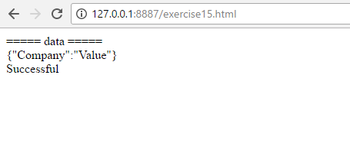

16. Add cross button on row and bind click function which make a delete request to server, after success event remove the row from dom

<html>

<head>

<link rel="stylesheet" href="style.css">

<script src = "https://ajax.googleapis.com/ajax/libs/jquery/3.2.1/jquery.min.js"></script>

<title>

Title Example

</title>

</head>

<body>

<table class = "boundary">

<thead>

<th>ID</th>

<th>Employee Name</th>

<th>Designation</th>

<th>Department</th>

<th></th>

</thead>

<tbody>

<tr>

<td>1</td>

<td>A</td>

<td>Manager</td>

<td>Information Technology</td>

<td><button>&#x2716; </button></td>

</tr>

<tr>

<td>2</td>

<td>B</td>

<td>HR</td>

<td>Information Technology</td>

<td><button>&#x2716; </button></td>

</tr>

<tr>

<td>3</td>

<td>C</td>

<td>Employee</td>

<td>Information Technology</td>

<td><button>&#x2716; </button></td>

</tr>

<tr>

<td>4</td>

<td>D</td>

<td>Manager</td>

<td>Marketing</td>

<td><button>&#x2716; </button></td>

</tr>

<tr>

<td>5</td>

<td>E</td>

<td>HR</td>

<td>Marketing</td>

<td><button>&#x2716; </button></td>

</tr>

<tr>

<td>6</td>

<td>F</td>

<td>Employee</td>

<td>Marketing</td>

<td><button>&#x2716; </button></td>

</tr>

</tbody>

</table>

<script type="text/javascript">

$(document).ready(function() {

// console.log("Hello world");

$("button").click(function(){

$(this).parents('tr').first().remove();

});

console.log("outside ajax");

});

</script>

</body>

</html>

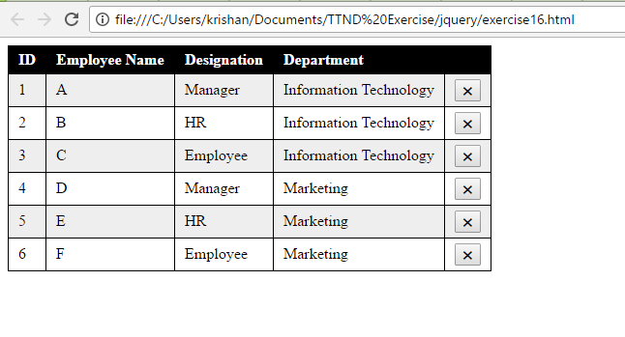

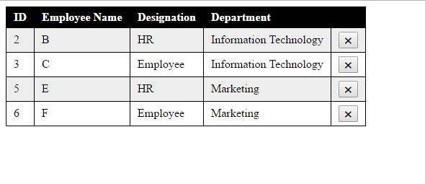

* Git Exercise Second

<html>

<head>

<meta name="viewport" content="width=device-width, initial-scale=1.0">

<link rel="stylesheet" href="style1.css">

<link rel="stylesheet" href="..\bootstrap\New folder\bootstrap-3.3.7-dist\css\bootstrap.min.css">

<script src = "https://ajax.googleapis.com/ajax/libs/jquery/3.2.1/jquery.min.js"></script>

<script src="..\bootstrap\New folder\bootstrap-3.3.7-dist\js\bootstrap.min.js"></script>

<title>

Bootstrap

</title>

</head>

<body>

<div class = "container">

<div class = "jumbotron col-md-9 jborder">

<label>Name:*</label>

<input type="text" name="uname" id="name" required>

<label>Email:*</label>

<input type="email" name="email" id="email" required>

<button id="add">ADD</button>

</div>

<ul id = "card"></ul>

</div>

<script type = "text/javascript">

$(function() {

$('#add').click(function() {

var name = $('#name').val();

var email = $('#email').val();

var el = $('<li><h3>' + name + '</h3>\

<h3>' + email + '</h3>\

<button id="del">DELETE</button></li>');

$('#card').append(el);

$('#form').trigger('reset');

$('#card').on('click', '#del', function() {

$(this).parent().remove();

});

});

});

</script>

</body>

.jborder

{

border: 2px solid grey;

}

#add

{

background-color: grey;

color:white;

}

label, #add

{

margin-left: 15px;

}

ul {

margin-top: 30px;

margin-left: auto;

margin-right: auto;

margin-bottom: auto;

padding: auto;

}

li {

list-style: none;

float: left;

margin-right: 10px;

margin-bottom: 10px;

width: 400px;

height: 150px;

background-color: lightgray;

border: width border-style color;

}

#del {

background-color: gray;

border: none;

color: white;

padding: 7px 12px;

text-align: center;

text-decoration: none;

display: inline-block;

font-size: 14px;

margin-left: 314px;

margin-top: 10px;

}

#card {

width: 400px;

height: 300px;

}

h3{

font-size: 22px;

margin-left: 20px;

}

